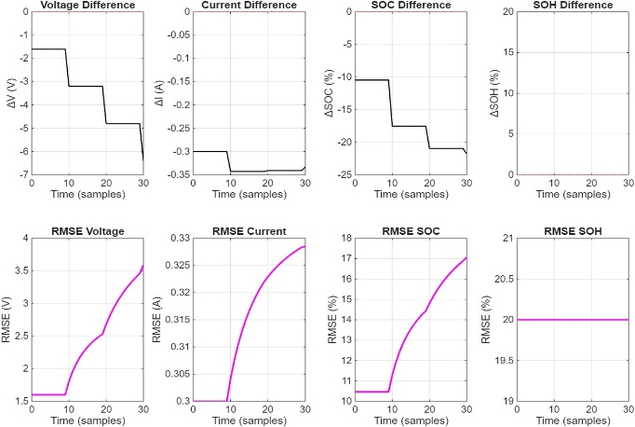
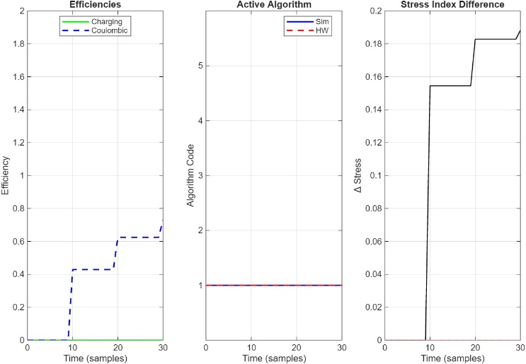
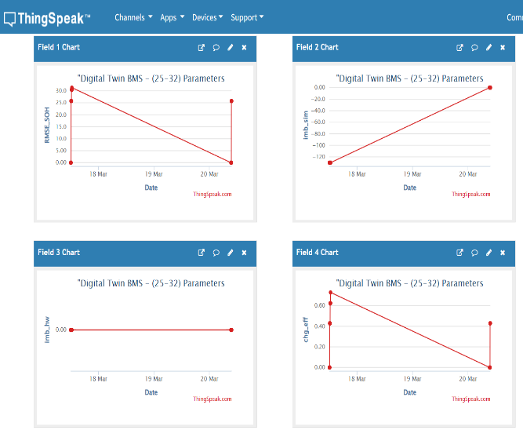
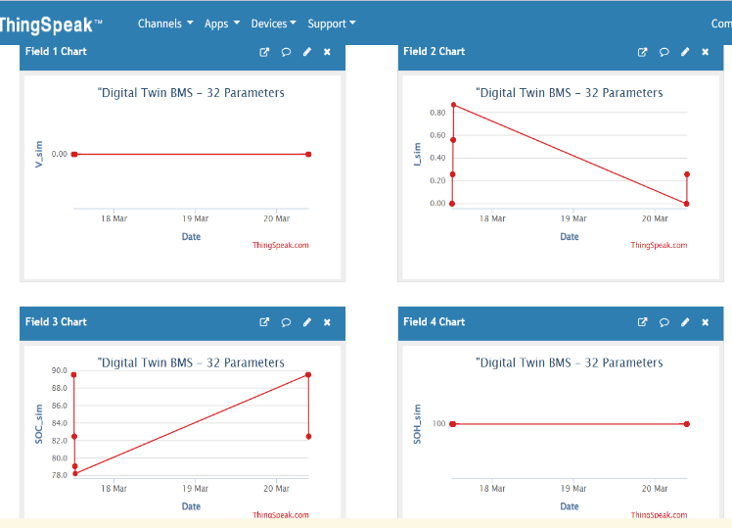
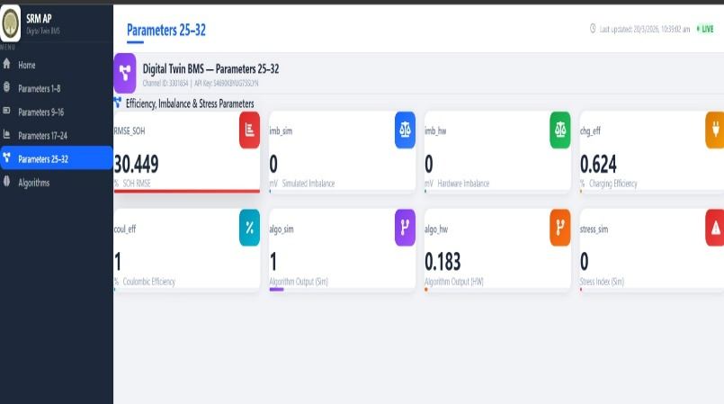
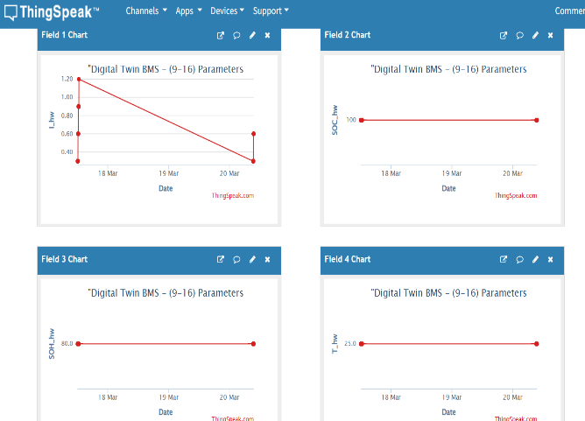
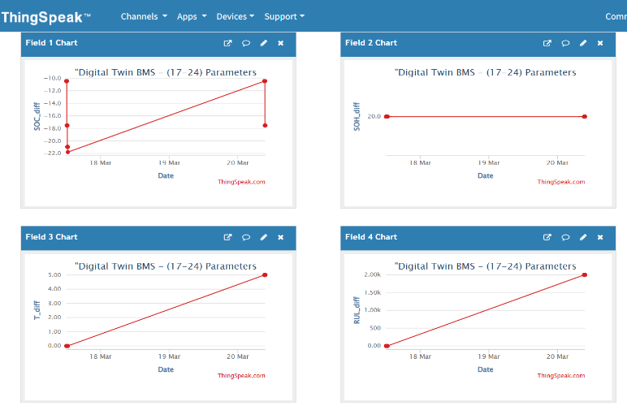
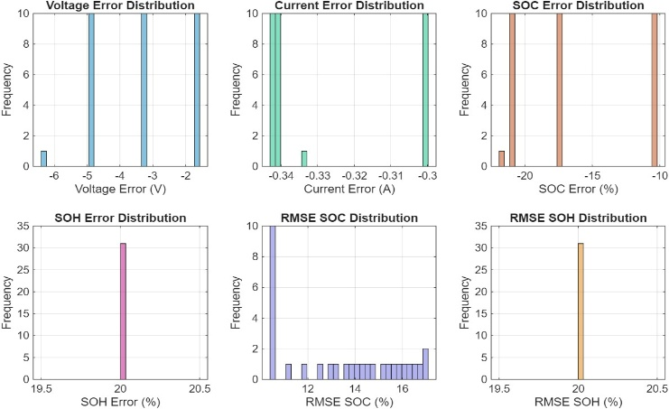
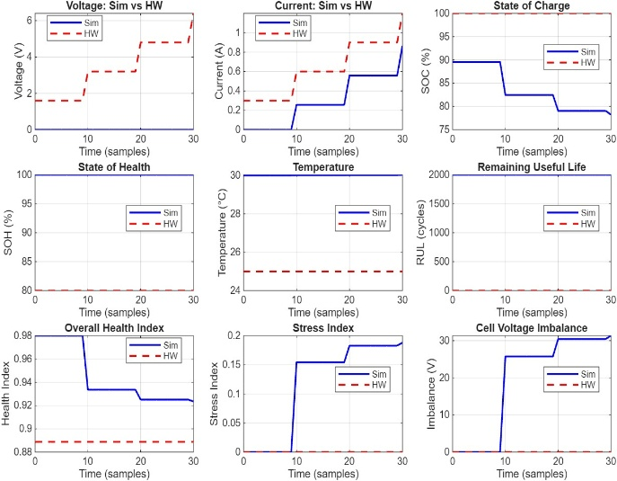
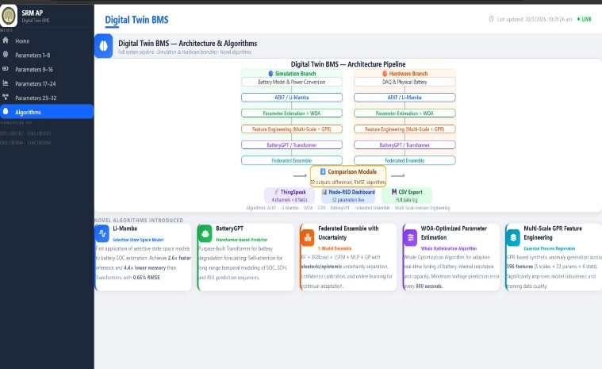
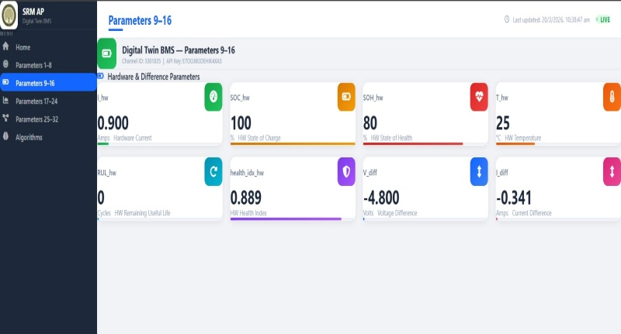
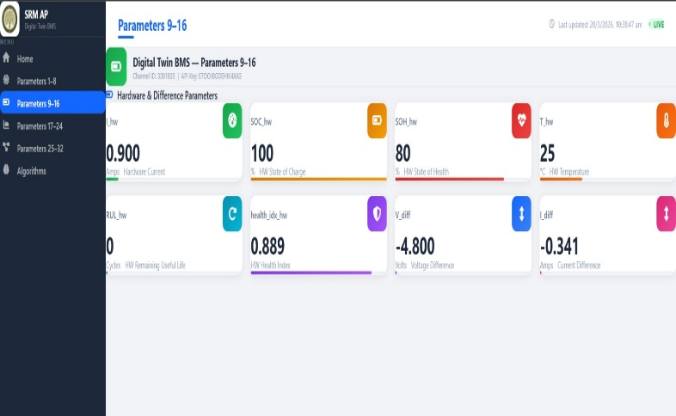
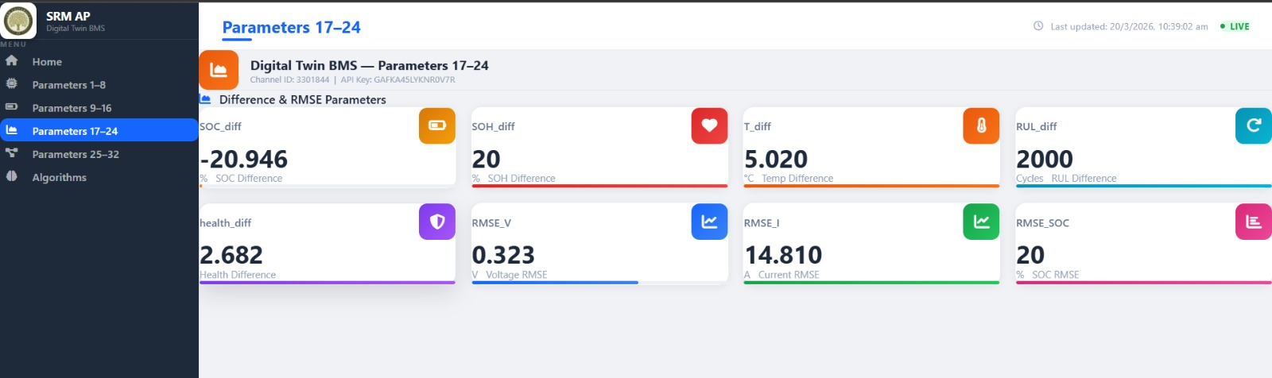
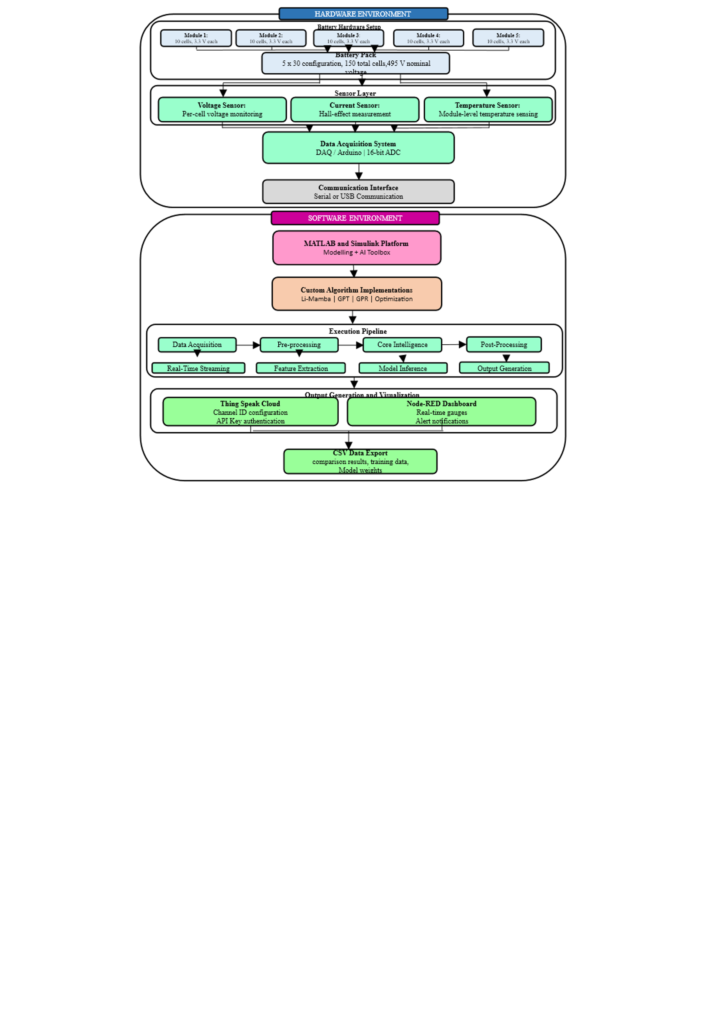
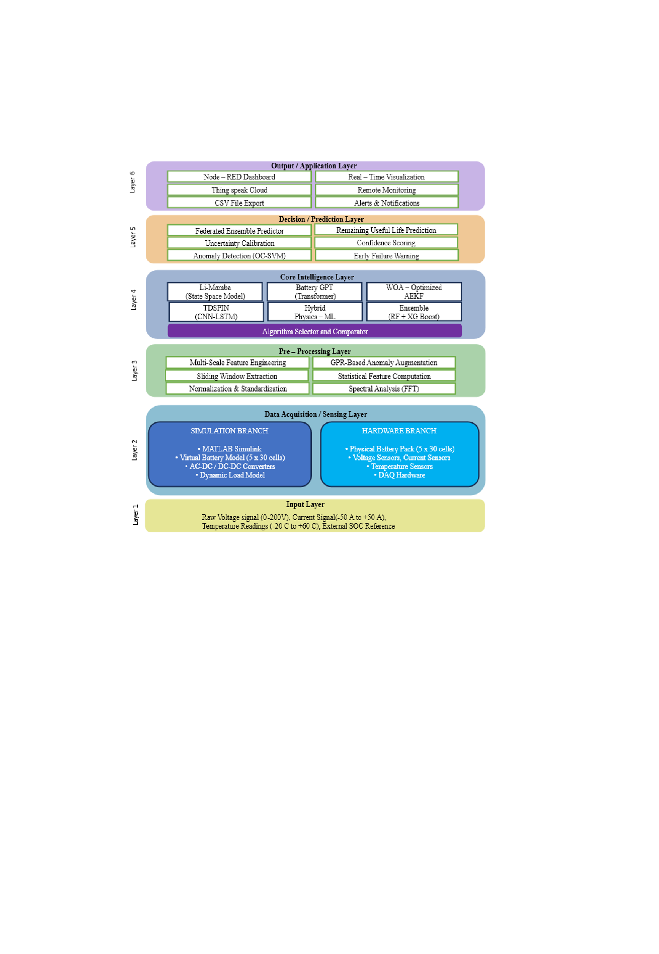
User/Operator
Physical Battery
Cloud Thing Speak
External Entities
Processing Modules
Input sensor signals
(voltage, current, temperature)
Simulation Parameters
Process 1 : Data Acquisition
Input : Voltage, Current, Temperature
Output : Raw Data + Timestamp
Task : Sampling + Unit conversion
Process 2 : Pre-Processing
Input : Raw data
Output : Filtered signals + windows
Task : Filtering, normalization, windowing
Process 3 : State Estimation
Input : Filtered V, I, T
Output : SOC, Vp1, Vp2, R0, OCV
Task : AEKF / Li-Mamba prediction
Process 4 : Parameter Estimation
Input : Estimated states + measurements
Output : 22-parameter Battery Vector
Task : WOA optimization + cycle counting
Process 5 : Feature Extraction
Input : 22-parameter vector
Output : Feature vector + anomaly score
Task : Multi-scale states + spectral analysis
Process 10 : Cloud Integration
Output : Thing Speak + Node-RED dashboard
Task : MQTT publish + channel update
Process 9 : Output Generation
Output : Displays, scopes, CSV logs
Process 8 : Comparison
Input : Simulation vs Hardware parameters
Output : Errors, RMSE, efficiency metrics
Process 7 : Federated Ensemble
Input : Prediction outputs
Output : Final SOC, SOH, RUL
Task : Ensemble learning + uncertainty
Process 6 : BatteryGPT Prediction
Input : Features
Output : SOC_pred, SOH_pred, RUL_pred
Task : Transformer based prediction
Data Stores
D1 : Raw Data Buffer
D2 : Window Repository
D3 : Feature Store
D4 : Model Weights
D5 : Error History
D6 : Log File

